The History of the

Preibisch / Ehrhardt Families

as Chronicled by

Kerstin Potter

2011- 2012

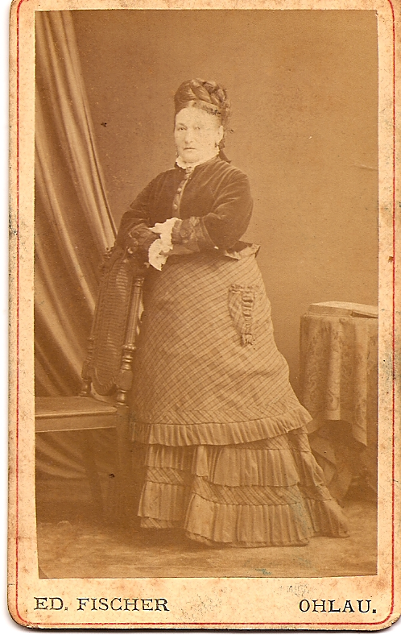
Preibisch Family

Herz / Schönfeld

Bertha Herz married Wolf Schönfeld in Ohlau in

southwestern Silesia (now Olawa in Poland) in 1856.

While Wolf’s family was Protestant, Bertha’s background

was probably Jewish. The question of faith was never

mentioned, but we know that they celebrated elaborate

Christmas feasts. They had three children: Anna, Ruscha,

and Georg. Their household is decribed in Ruscha Schönfeld’s

memoirs as filled with the arts, especially music and poetry.

Wolf’s grandfather had been a sculptor at the court of King
Friedrich-Wilhelm IV, and his brother was a composer and
music director in Breslau. Wolf was a businessman, but we do not
know in what business. We do know that he loved the arts, especially
the classics. He had memorized extensive works of poetry and
entertained many well known poets and writers of the time in his
household on week-ends, among others, Paul Heyse, Emmanuel
Geibel, and Max Kalbeck, Wolf’s other great passion was chess.

The family played music daily - Bertha had a good singing voice and was an excellent pianist, and all children studied music early on. Week-ends were often spent in the company of visiting music lovers; family and friends would play string quartets and piano, perform songs of the classical composers, or try out contemporary works by Brahms and Schumann, or even the newest pieces by Wagner.

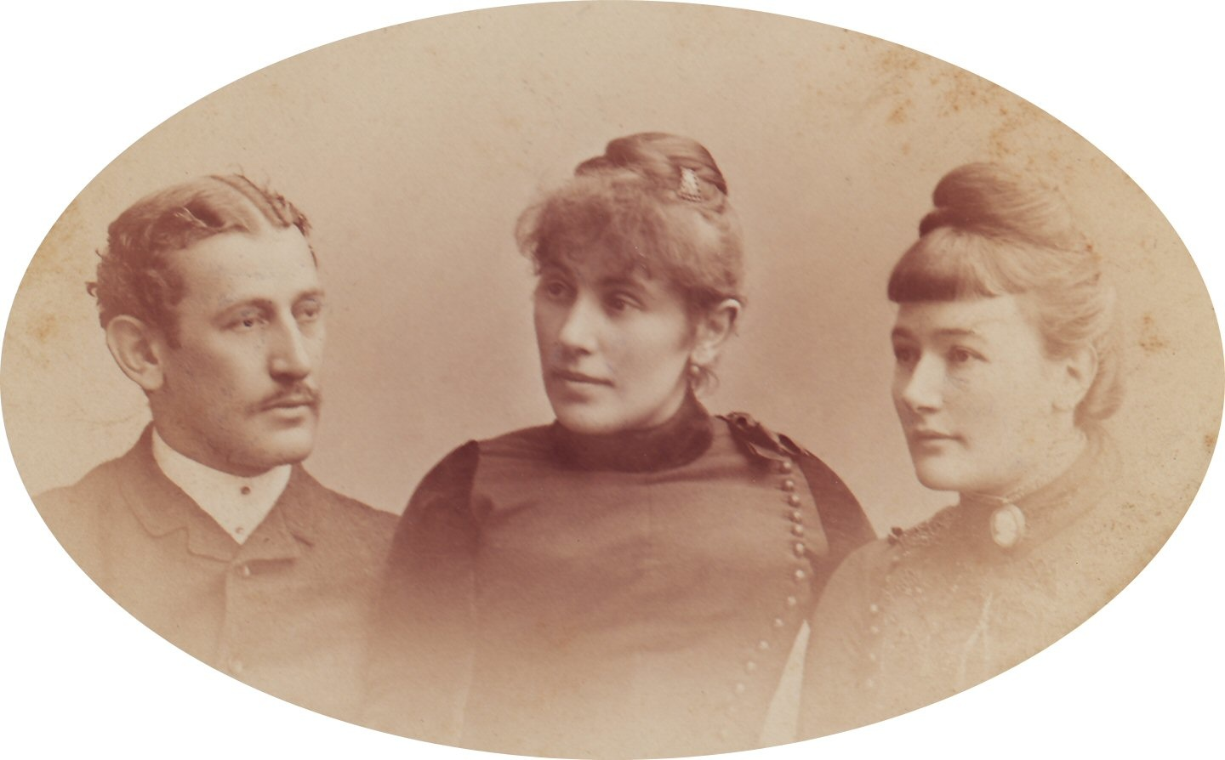
Georg grew up to become a world traveler. After his studies, he went on extensive trips abroad, often bringing home exotic souvenirs for his sisters, such fabrics and precious stones. The blue moon-and-star pin was made from a handful of sapphires brought back from India. Georg died in India of a tropical disease in 1903 at a young age. He had no children.

Ruscha went on to become a well-known pianist and founded her own music school. She befriended many famous people, such as Brahms, v. Bülow, and others. Her interesting life is chronicled in her memoirs. Her daughter Ellen, a cellist, married the Dutch architect Hendrik Wijdeveld and moved to Holland. See “Dutch Relatives.”

Anna married Prof. Dr. Karl Preibisch, to eventually become Vivi’s grandmother, see “Schönfeld / Preibisch”.

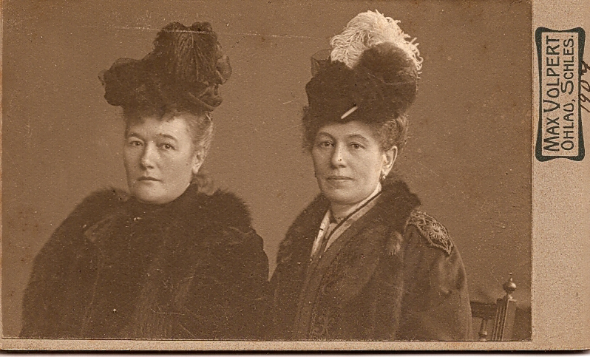

The two Schönfeld sisters, Anna and Ruscha, remained life-long friends. They visited often and helped each other through difficult times and losses. Ruscha’s son Fritz had a fatal accident* at age 17, and one of Anna’s three sons, Walther, died in WWI, the other two were seriously wounded. When Ruscha was 46, her husband Eugen Kohn died unexpectedly. A businessman and entrepreneur, he left her with a mountain of debt. This is when Ruscha made the transition from occasional performer to professional musician, with the support of her sister.
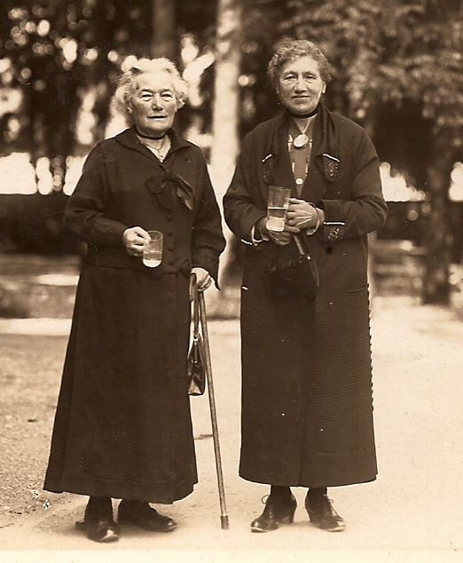
After Anna’s husband died, she moved into a retirement home
in Halle (in Saxony-Anhalt) near her son’s family.
Ruscha, who was trying to survive as an artist in Berlin,
visited often. The two elderly sisters even undertook travels
together. The photo taken in 1928 during one of their trips,
in the Bavarian resort town of in Bad Tölz. The sisters are
walking together in the spa gardens while “taking the waters”
for health.

Anna died peacefully in her retirement home,
while Ruscha had to emigrate to Holland at age
75 to escape Nazi persecution. When the Nazis invaded the
Netherlands, miraculously, Ruscha was unharmed.
There are three contrasting accounts as to how this came
about (see next page). “Groszmutter” Ruscha lived out her
days among her Dutch family. She died aged 89 in Utrecht,
playing her beloved piano until the end.

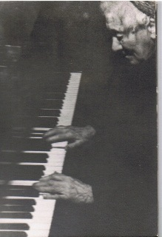
*The accident referred to was a possible suicide; Fritz and his classmates had long suffered under an extremely sadistic teacher. Eventually, a small group got together and took a solemn vow to kill him. The lot fell on Fritz to do the actual shooting.

Instead, on the morning of the planned assassination, Fritz was found in his room, - shot dead.
Family Mystery: Who saved Ruscha Schönfeld-Kohn?

Version 1, as told by Hendrik Wijdeveld (Uncle Dutchy):

When the Nazis invaded the Netherlands, Ruscha’s name was placed on the list for
deportation. Greatly concerned for her safety, her son-in-law Hendrik Wijdeveld made an appointment with the German officer in charge, taking along his life’s savings, just in case. He pleaded with the officer for Ruscha’s life, but was told that there was nothing he could do. Toward the end of the interview, the officer briefly left the room. Hendrik knew what was expected: He left the bag containing all of his money on the officer’s desk and left quickly. – Ruscha’s name was never called.

Version 2, as told by Maarten and Wendela Kloosterman (based on family stories)

When the Nazis invaded the Netherlands, Ruscha was living with her daughter and son-in-law in Elkerlijk, a school for arts and architecture, which he had designed and built. Their apartment was always filled with beautiful music and lively discussions on visual arts. Apparently this cultural oasis in the midst of war attracted a young German officer, who visited frequently. He was reportedly seen during one of the house concerts looking out of the window and murmuring “Scheisskrieg” (f...war) to himself. It is thought that this officer’s intercession saved Ruscha from deportation.

Version 3, as told by Tineke Polee Wijdeveld (eye-witness, wife of Roland Wijdeveld)

In an e-mail August 10, 2012, Tante Tineke writes: “None of the stories you heard about Groszmutter being saved from being deported is true. I'm very sorry to have to tell you that Dutchy, very much to the distress of his family, suffered from pseudologia fantastica, i.e. he could make up and tell beautiful stories, which he ended believing himself.” - Here follows her account:

When the Nazis invaded the Netherlands, there never was any danger about Groszmutter being sent to Poland because of her having Jewish blood. She was a Protestant and in the then Dutch civil administration people were registered by their religion and never by race. The real danger was in the fact that she was a person without nationality, because everybody who left Germany after the Nazis took over automatically lost their German nationality. So about a year after the Germans occupied Holland, Roland went to the civil administration office in Bilthoven. We knew some people who worked there and knew we could trust them. They illegally made Groszmutter a Dutch protestant civilian, which was very brave of them, because they could have been imprisoned and perhaps even shot by the Germans because of that. I know that they helped quite a few persons in that way, never boasted about it, and are really and truly unsung heroes of the war.

So when the Germans ordered everybody to get a special identity card, which you had to have with you all the time and which was indispensable to obtain food coupons, she was issued the same card as every other Dutchman and never got into any trouble. Jewish people got a capital J in their card and were shortly after summoned to report for transport to Poland.

That is what really happened.

-----------------------------------------------------------------------------------------------------------------Ruscha’s daughter Margarete, “Grethe”, a violinist and music teacher, also fled Germany and moved to Holland with her family to escape the Nazis. Their story is a deeply disturbing one (see next page).

Grethe’s Story

as told by Tineke Polee Wijdeveld, eye-witness
with additions based on info from http://www.joodsmonument.nl in parentheses

Grethe married the Jewish Siegbert Davidsohn, who worked at the Dresdener Bank (in Berlin?). They had two children. Eva, 1915 and Joachim, 1917.

After the Nazis took over, they moved to Amsterdam, into the house at Vossiusstraat 50, that Ellen and Dutchy had left when they went to France to start something like Wright's Taliesin on the Mediterranean coast.

Siegbert then got work at a Dutch bank. Eva married another Jew, Heinz Bleiweiss.
In 1942 she had a baby, Yehudi. (His full name was Jehudi Joachim, named after her brother?). (They lived at Haarlemmermeerstraat 105 I, Amsterdam).

Joachim was taken prisoner by the Germans in 1941 during a razzia in Amsterdam, transported to Mauthausen and shot there six weeks later. "Auf der Flucht erschossen" was the message his parents got. (Three obituaries were published in the Joodsche Weekblad by his family, his fiancee, and his business partners. None of them mention the cause of his death.)

In 1943, the Davidsohns were summoned to report for transport to Poland. When we heard about that, Roland and I went to Amsterdam with Ellen's identity card, because the sisters were great look-alikes, and begged Grethe to come with us. Roland had a friend in the resistance who could provide them with false identity cards and a place to hide. But they refused. Grethe said that she would start a boarding house in Poland and that everything would be alright.

They were transported to Poland and killed on the same day, June the fourth 1943 in Ratibor. The Bleiweiss family, with their (6-month-old) baby, were killed a month later.

A terribly sad story.

In defense of Grethe I must say that none of us, at that time, realized that the Germans really were killing the Jews, instead of transporting them to a new homeland. It was beyond our imagination that a civilized country was able to do such horrible things to innocent people.

---------------------------------------------------------------------------------------------------------------

Here are their dates (from http://www.joodsmonument.nl):

Margarete Davidsohn-Kohn: born in Beuthen, April 13, 1886 – died in Ratibor June 4, 1943
Siegbert Davidsohn: born in Breslau, June 13, 1888 – died in Ratibor, June 4, 1943
Joachim Davidsohn, born in Berlin, January 20, 1917 – shot in Mauthausen, Aug 4, 1941
Eva Bleiweiss-Davidsohn, born in Berlin, Mar 4, 1915 – died in Ratibor, July 9, 1943
Heinz Nuchem Bleiweiss, born in Berlin, July 2, 1915 – died in Ratibor, July 9, 1943
Jehudi Joachim Bleiweiss, born in Amsterdam, Feb 19 – died in Ratibor, July 9, 1943

Dutch Relatives
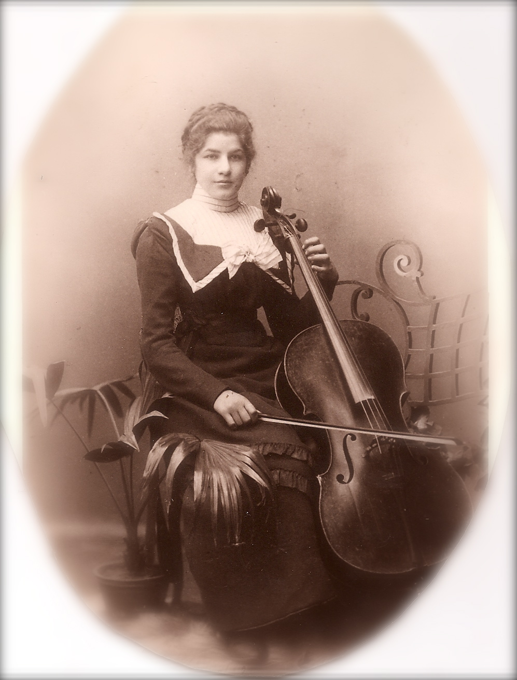
Ellen Schönfeld-Kohn, Ruscha’s daughter, studied the cello and eventually became a professional performer and teacher. After high school, she spent a year in England as an au-pair. Here she met Hendrik Wijdeveld, then a Dutch student of graphic design and architecture, called “Dutchy” by his English friends. They married, and set up their household in Amsterdam.

Together, they dedicated their lives to the arts – Ellen through music, and Hendrik through visual arts and architecture. They founded “Elkerlijk” , a school for arts and architecture in which they offered classes, studios, opportunities for an exchange of ideas, and the quiet environment to develop creativity.


Hendrik became one of the leaders of the Nieuwe Stijl (similar to Bauhaus
in Germany) introducing radically new concepts in architectural thinking.
When he turned 100 years old, he organized a retrospective of his art, called
“My First 100 Years”. I met him several times, and he struck me as always
full of new ideas, intense, and incredibly passionate about life. On the right,
he is seen with his son Wolfgang.

Ellen and Hendrik (still called “Dutchy” by his wife), had three children:
Wolfgang, Roland, and Ruscha – named after her grandmother. Wolfgang,
and Ruscha are seen left and right on photo below, with family friend).

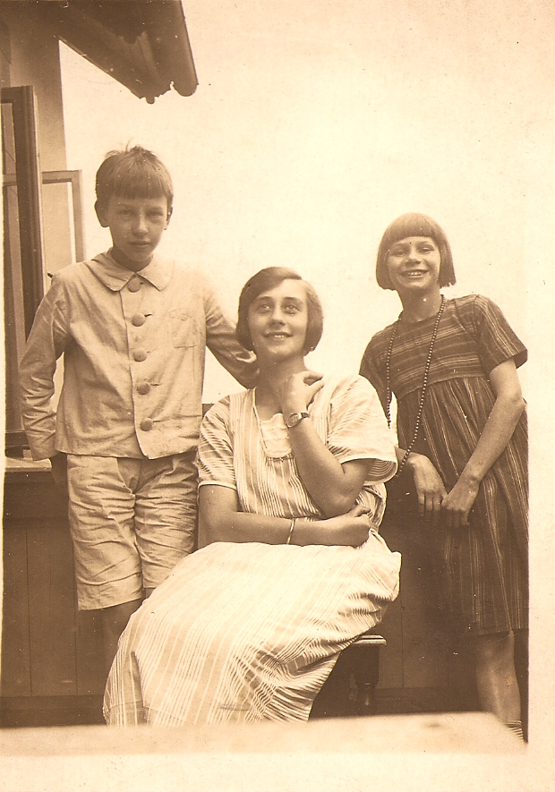
Wolfgang (“Wokke”) became a well-known composer and pianist – famous for his music, as well as his womanizing. As an adult, he lived equidistant to several of his ex-wives, whom he visited on a weekly basis.

Roland became a successful businessman despite his father’s efforts to mold him into an artist like himself. He married Tineke Polee. As an adult, Roland sustained a spinal cord injury, but continued his work, eventually heading his own publicity company.

Ruscha became a designer and illustrator of children’s books. Many of the small boxes painted with miniatures in my household are her work. She married Jan Kloosterman, a well known gynecologist and early supporter of Free Choice. They had seven children: Jan, Maarten, Yngeborg, Peter (died age 19 in an accident), Yme, Sipp, and Wendela.

Vivi and George kept up correspondence and occasional visits to the Dutch side of the family. Poi (Lynn Hendrikje) is named after Uncle Dutchy, and Jan after Ohme Jan Kloosterman. I spent a great summer vacation with my seven cousins when I was 15.

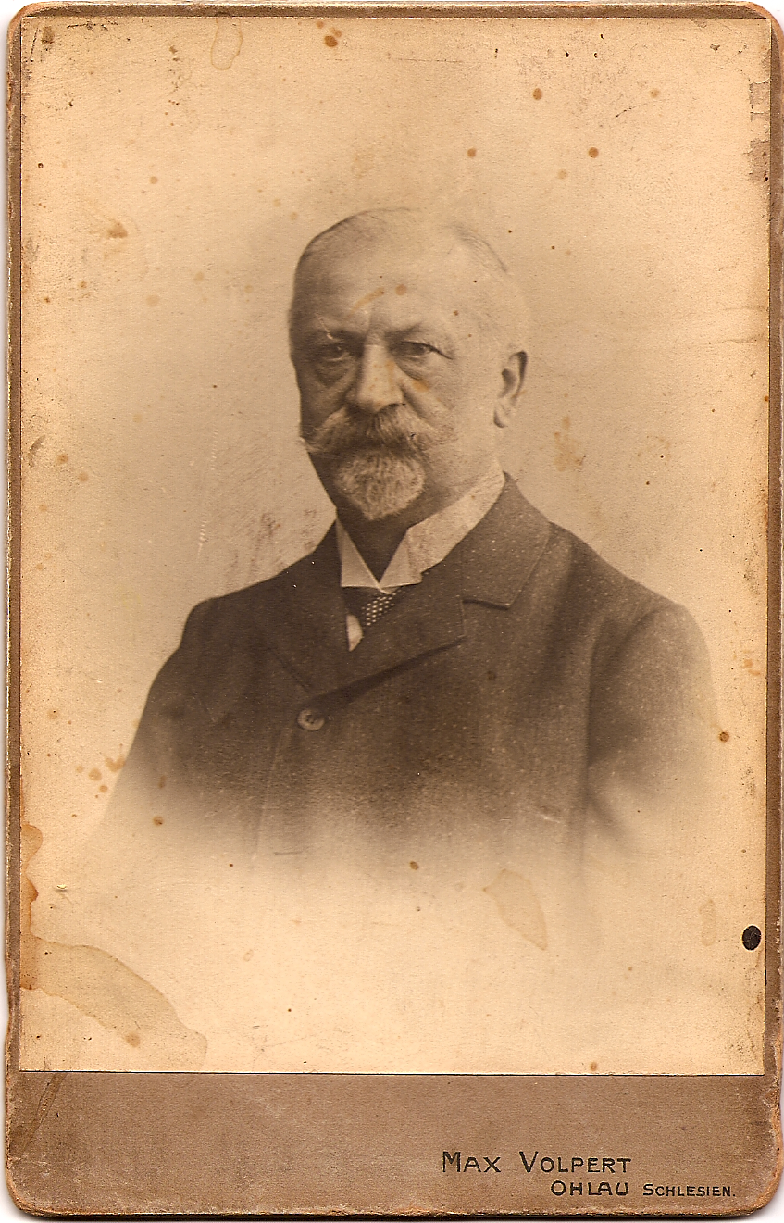
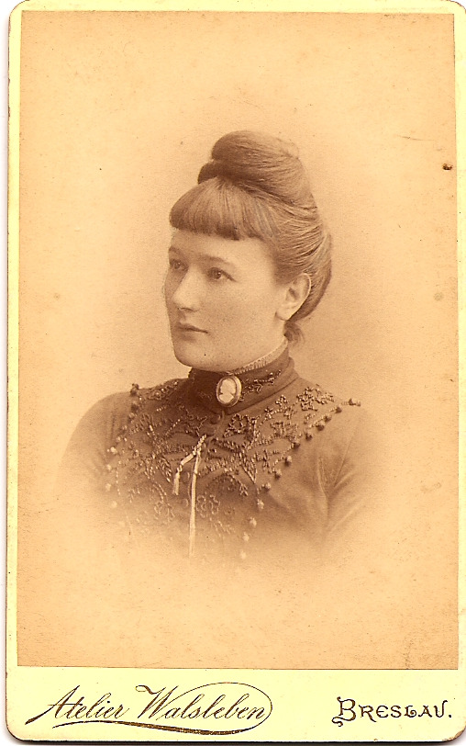
Schönfeld / Preibisch

Anna Schönfeld and Prof. Dr. Karl
Preibisch were married in 1874 in Breslau
in Silesia (now Wroclaw in Poland).

Karl came from a long line of academics.
His earliest known ancestor served as the
president of Leipzig University in 1580.
Karl was a Gymnasial-teacher, whose field
was the Classics, i.e. Latin and Greek. He
published his doctoral thesis in 1869 on the
use of subjunctives in Thucydides (“De
comparativi cum comparata re coniuncti usu
Thucydideo”). He valued academics and must
have been gratified that all his children
obtained a PhD.

Anna came from a very musical family (see “Herz / Schönfeld”) and saw to it that the tradition of music was continued in her household. She herself was a good pianist, and, planning ahead, the children learned instruments which would eventually make up a string quartet.

Anna and Karl had three sons, Hans, Walther, and Werner. All three became teachers; the oldest, Hans, taught Classics and Physical Education, the second, Walter, Latin and Music, the youngest, Werner, German Literature and French.

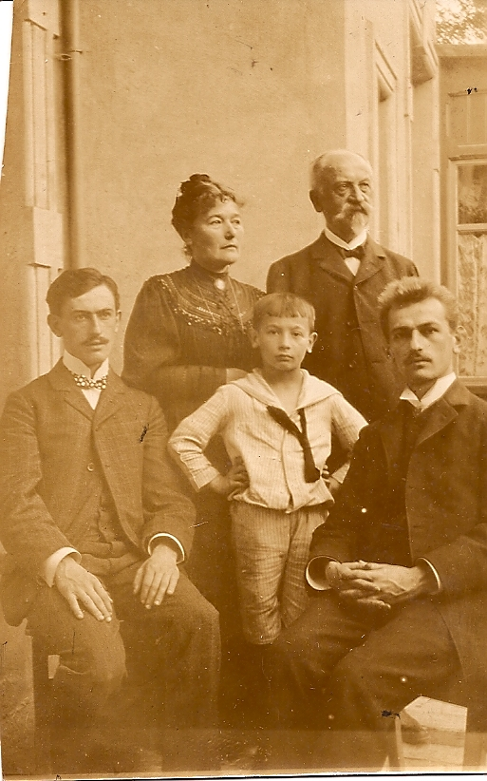
Hans was also a passionate violinist and prize-winning gymnast. When he returned from WWI, he was missing a leg and fingers of his left hand. This loss may have contributed to his reportedly unpleasant personality. Nevertheless, Louise married him as her second husband after she was widowed. Hans went on to become the director of a Gymnasium until the Nazis forced him into early retirement.

Walther loved music, especially opera, and wrote his thesis on Mozart’s Abduction from the Seraglio, arguing the benefits of combining Eastern and Western influences. He met Louise Ehrhardt when she approached him about private Latin lessons (see “Ehrhardt / Preibisch”). After two years of marriage, he was drafted into the army and was killed in France in the last weeks of WWI.

Werner was drafted as a 17 year-old out of high school. After the war, he completed his studies in France and spent most of his life abroad. He was denied a teaching license under the Nazis, so he taught at international schools in Greece and Japan. He published extensively on German-as-a-Second-Language, arguing that learning should be fun. He provided a safe haven in Japan for Vivi, when she left Germany in 1937. He died (took his life) at the end of the WWII, but only when he knew Vivi was safe.
Heise

The earliest mention of the Heise family is found in the Magdeburger Urkundenbuch of 1480: The Schoolmaster Heise apparently directed a school for secular students (as opposed to the schools connected to cloisters, for young men entering the church). Nothing more is known.

Another early Heise ancestor was a Lady-In-Waiting to the Archduchess of Hanover and Brunswick, in the 1780s. Originally from minor nobility, she became the beloved mistress of the Archduke. When she became pregnant, she had to leave the service of the Archduchess (and the Archduke) and was married to a wealthy merchant.

As a farewell present, the Archduchess gave her a beautiful pin with a portrait of herself, dressed in purple (see below). The Archduke gave her a house on the town square, furnished in the latest fashion, closets filled with sumptuous gowns, and a jewelry case containing precious rings, pins, and necklaces.

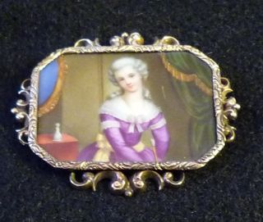

Unfortunately, we do not know her name. I believe her married name was Blank and her descendants later moved to Blankenberg (the term “Blanks of Blankenberg” being a source of great merriment for Omi and her brothers). Our Heises are descended from her second child, not the one fathered by the archduke, so there is no archducal blood in our veins, as far as we know. The exact relation of her to Robert Heise (see next page) is not clear to me, but the large collection of beautiful jewelry that has come down to us proves her existence.
Niekamp / Heise
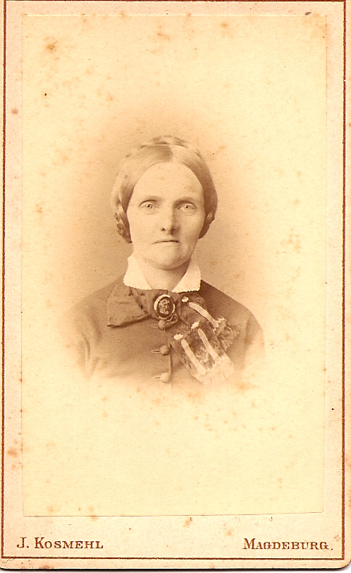
Louise Niekamp married Robert Heise March 20th,1859. Together,
they ran a large farm outside of Stendal (Altmark). They had three
children: Karoline (Lina) – born 1860 - , Carl, and Louise.

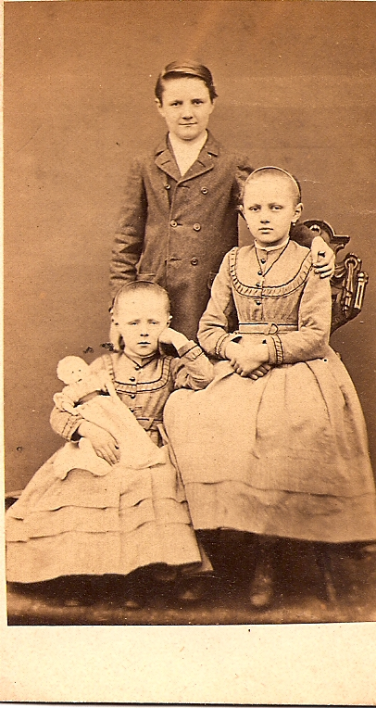
Carl left the farm to travel the world,
but would return regularly with presents
for his sisters (the silver goblin bracelet
from India is one of his gifts). He
eventually settled in South Africa, first
running an ostrich farm, but then, when
ostrich feathers went out of style,
changed to selling images of the Royals
(Victoria and Albert) to tourists. This line
of work was considered somewhat
embarrassing to the family....
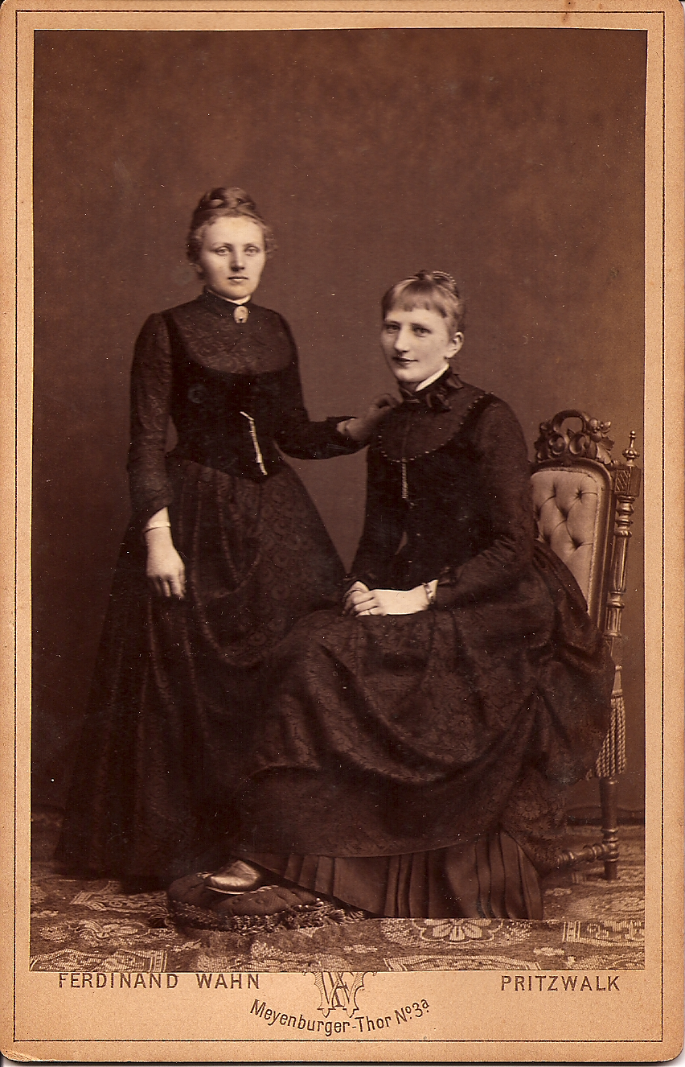
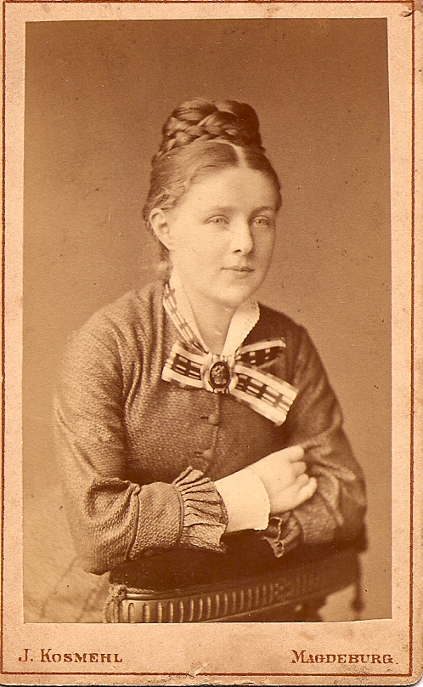

Lina and her sister Louise were When Lina had her first child,
very close. While still a teenager, a daughter, (Omi), she named her
however, Louise caught Louise, after her little
tuberculosis and died. sister (above).

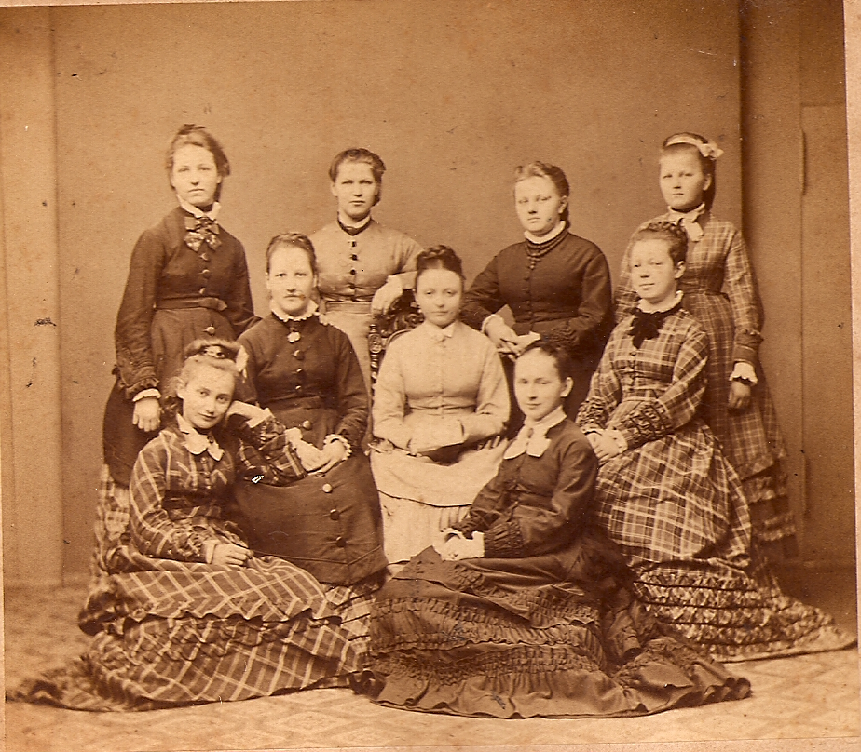
Lina attended an all-girls’ high school in Stendal.
After graduation (see photo, back row, second
from right) she stayed on the farm to help out her
parents.

She met her future husband Paul Ehrhardt,
as he was making his rounds as the District Veterinarian
to take care of the animals on her farm, see
“Heise / Ehrhardt”.

Mühlenbeck / Ehrhardt
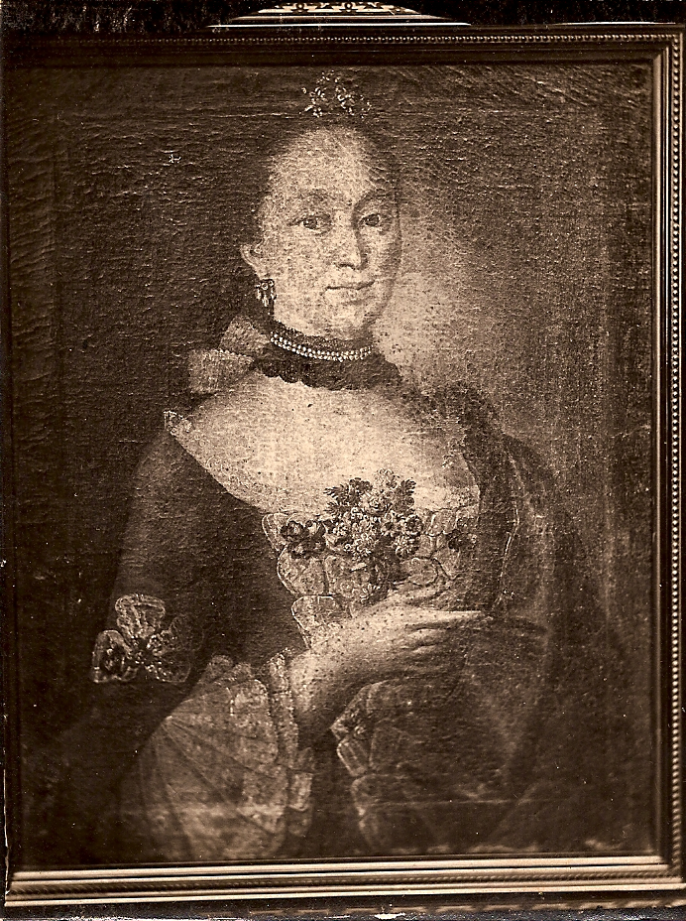
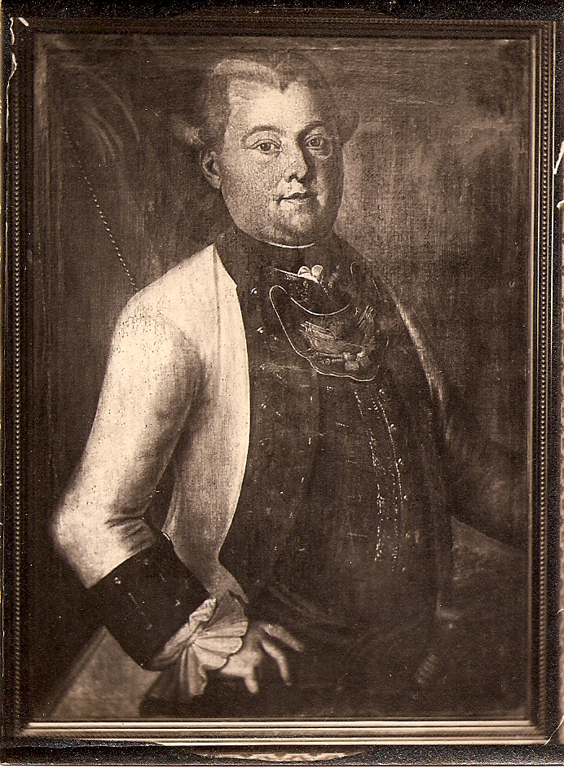
Hermann Ehrhardt came from a family
whose earliest known ancestors were
Johann Gottfried Ehrhardt (1724-1794)
and his wife Friderike Wilhelmine, nee
Böttcherin. Johann Gottfried was
Stadthauptmann, i.e. Head of Police /
Military for the town of Nordhausen,
Thuringia.

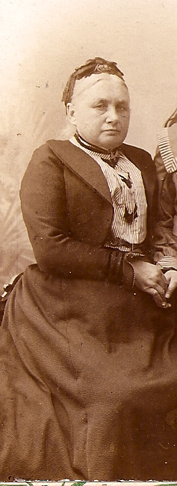

Hermann Ehrhardt married Dorothea Mühlenbeck about 1859. On the left is an image of Dorothea as grandmother in 1898. We have no image of Hermann.

We know very little about Hermann and Dorothea. We also do not know how many children they had. But we do know about their son, Paul Ehrhardt:
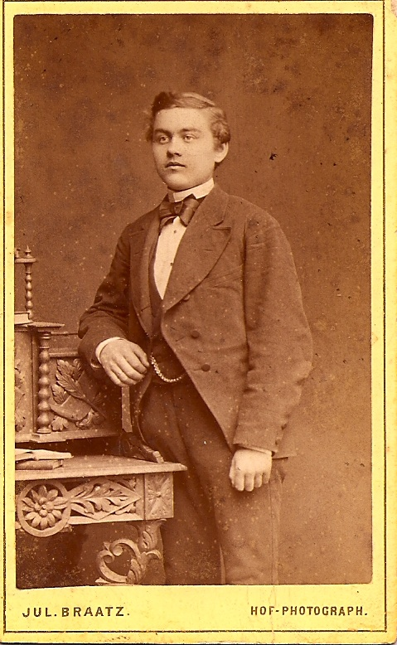
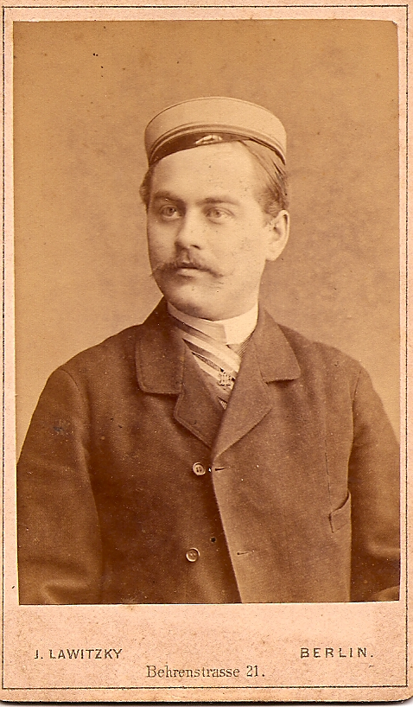
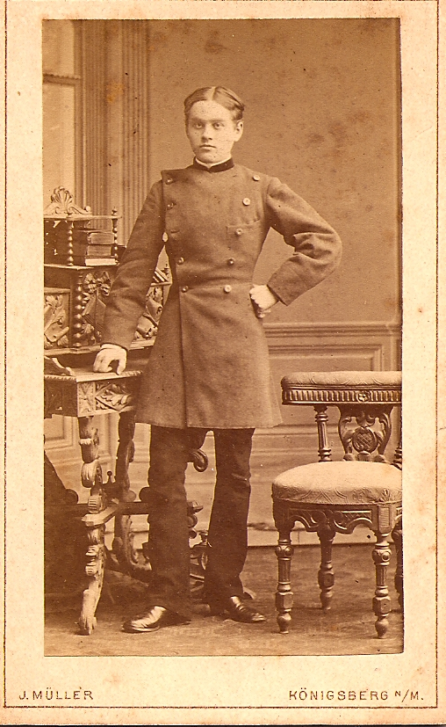

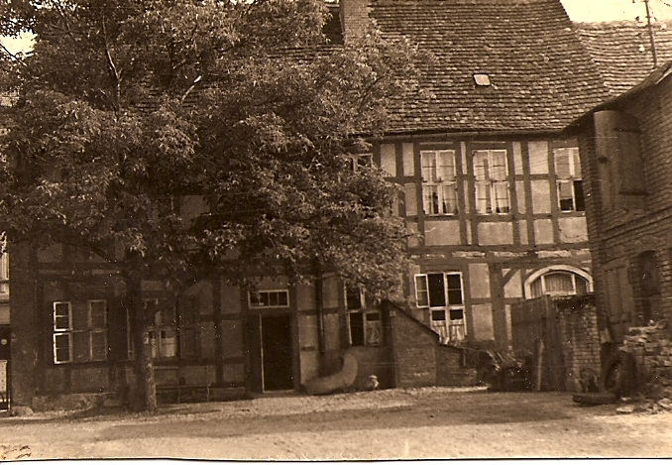
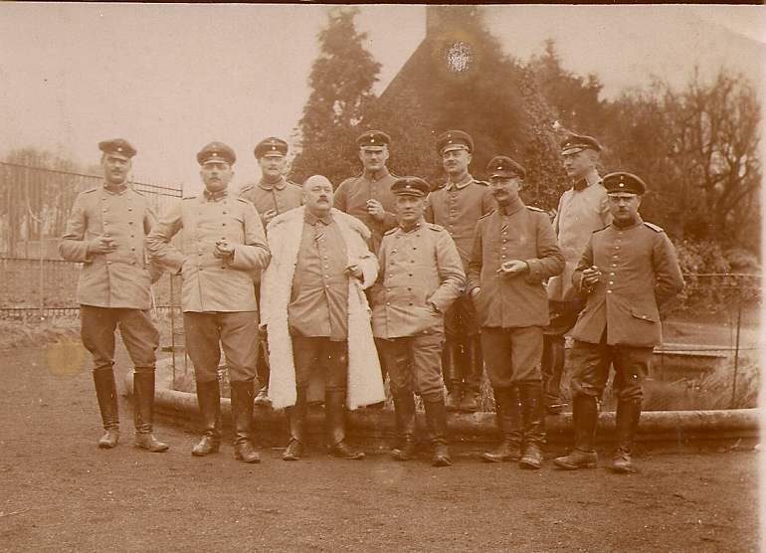
Paul was born in 1860 and attended a Gymnasium (first photo). At the completion of 10th grade, he qualified for entry into military service as an officer (second photo). He studied at the University to become a Veterinarian (third photo). In the last photo, he is proudly displaying the cap and colors of his fraternity. He went on to become the Distric Vet for Stendal, and served as a military Vet during WWI. He was able to purchase a house built for the Huguenots in the1656 in the town of Stendal, at Hook 2, which combined family space with his practice, stables, rooms for practicum students, and servants.
Heise / Ehrhardt
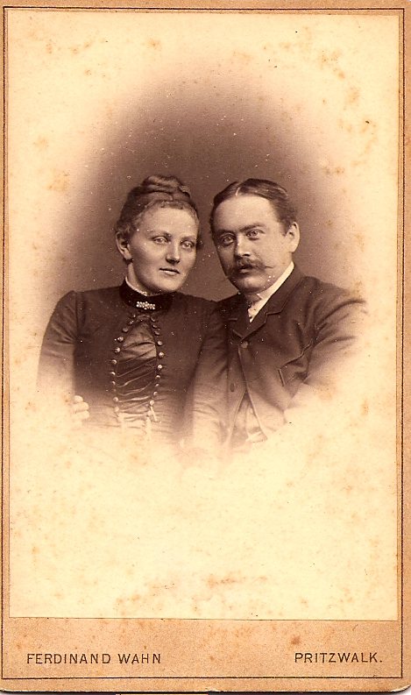
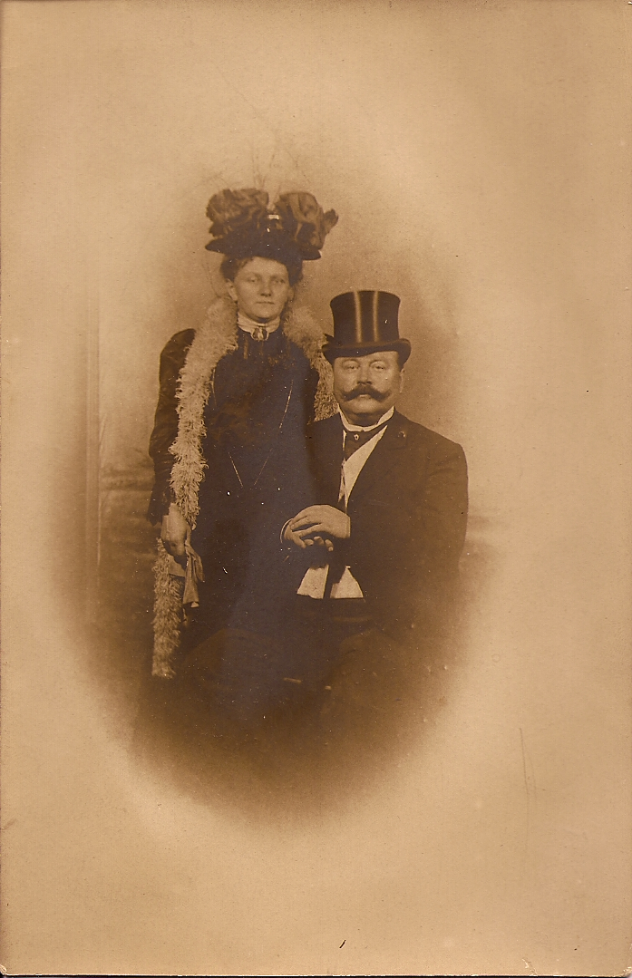
Lina Heise and Paul Ehrhardt were
married in 1888 in Stendal, Altmark.
See the engagement picture on the left,
on the right an anniversary picture.

Lina had expected to spend her life on
her family farm and was already 28
when they met. Paul had just established
himself as the District Vet and was
looking for a suitable wife.

While Paul saw after his patients and his
vet students, Lina managed a large house
hold, and a small dairy on the side.

The household at Hook 2 in Stendal
consisted of the coachman, several stable
boys, a dairy man, the veterinary
practicum students, the cook, and several
house maids. Usually there were visitors,
as well, relatives, friends, or colleagues.

Lina and Paul had three children in short succession: Louise, (also called “Lies”, Vivi’s mother) born 1889, Paul, born 1890, and Hans, born 1892. Below a photo taken 1893 with Paul, Lina, both grandmothers, Louise Heise and Dorothea Mühlenbeck, and the children. Hans, Louise, and Paul.

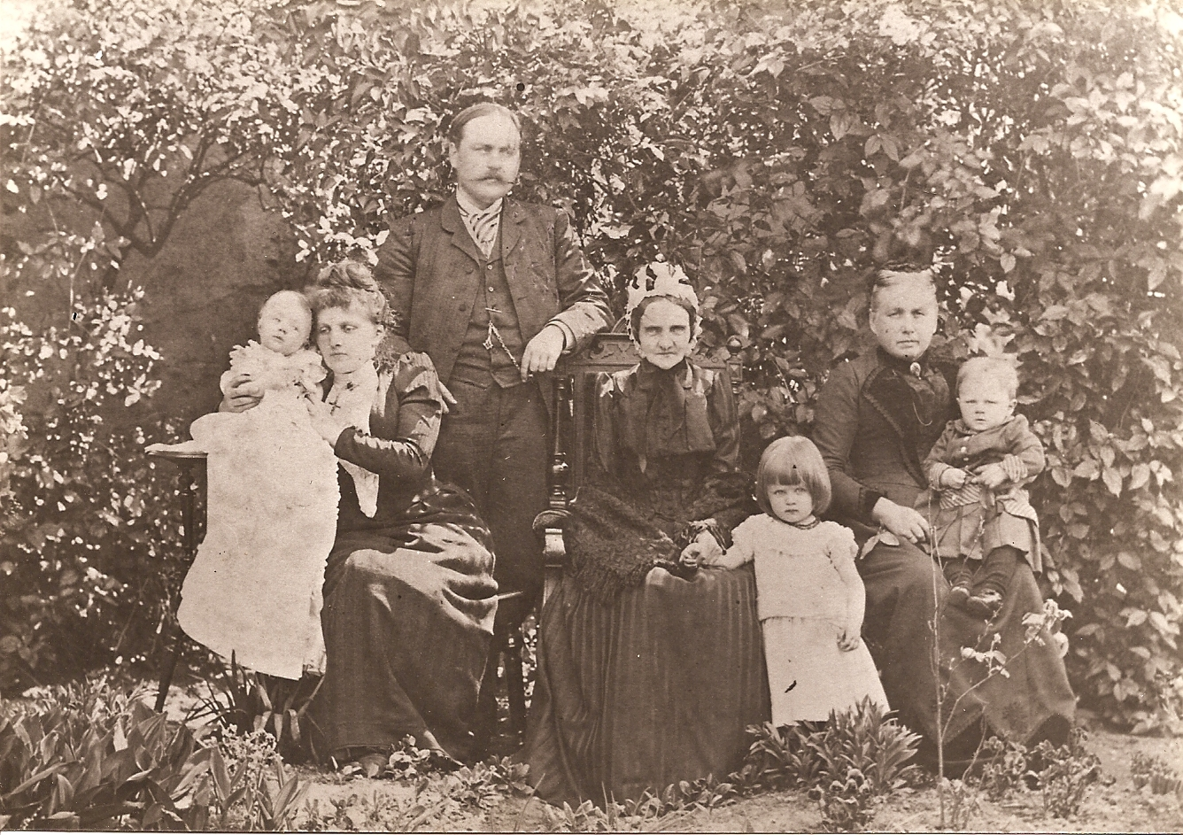

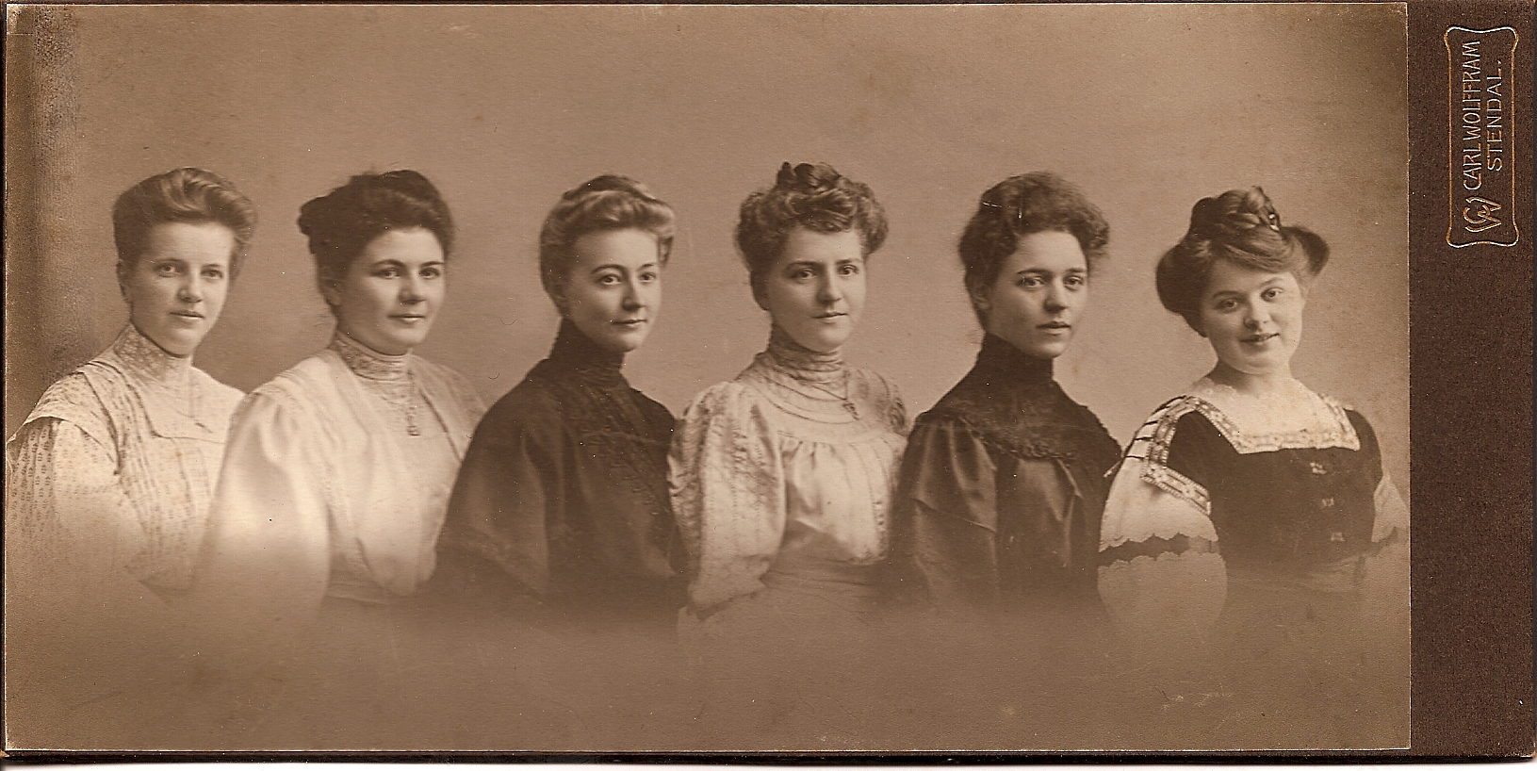

Louise (on right) was very smart and had ambitions to become a doctor. At the time, however, women were not allowed to enroll in medical school. She therefore attended a teacher’s college in Hamburg and graduated in 1910 with a degree in French and English– see graduation picture. She taught for two years and then married Walther Preibisch, see “Ehrhardt / Preibisch”.
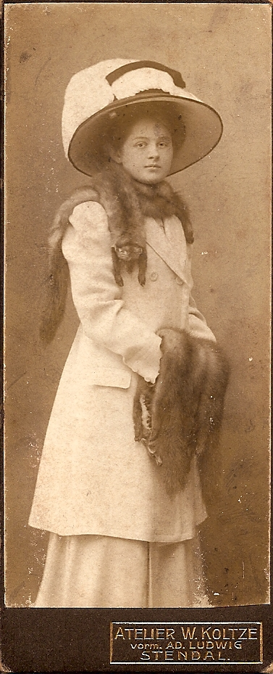
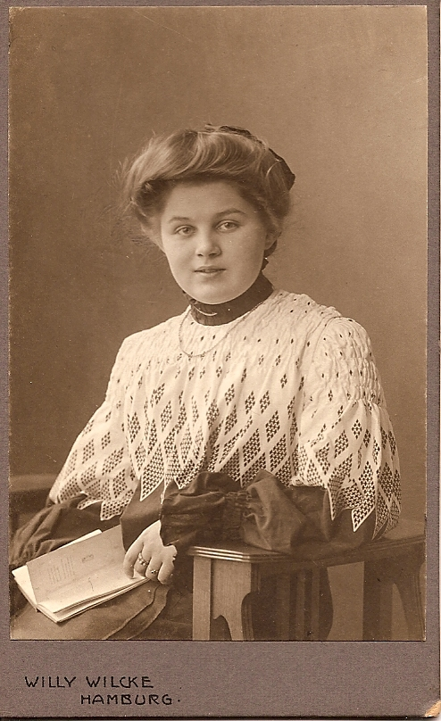
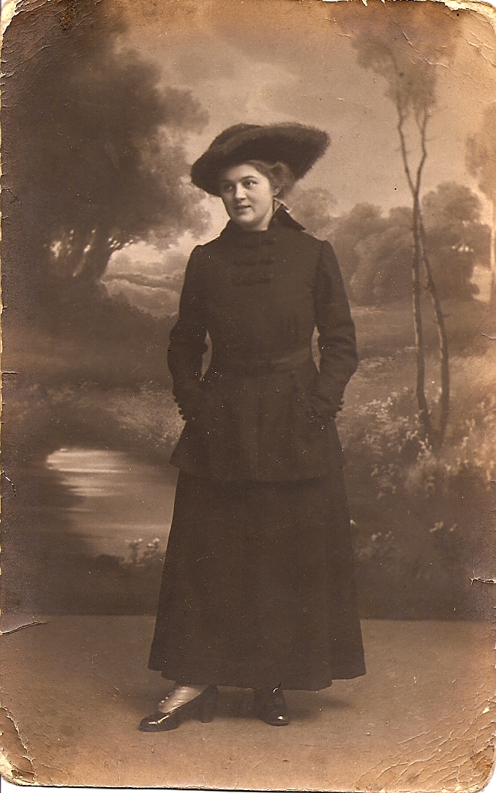

Louise also enjoyed dressing elegantly. At left, she
is a young teen, and posing for her first “grown-up”
portrait. Above she is 19, and studying for her exams.
On the right, she is 22 and newly engaged.

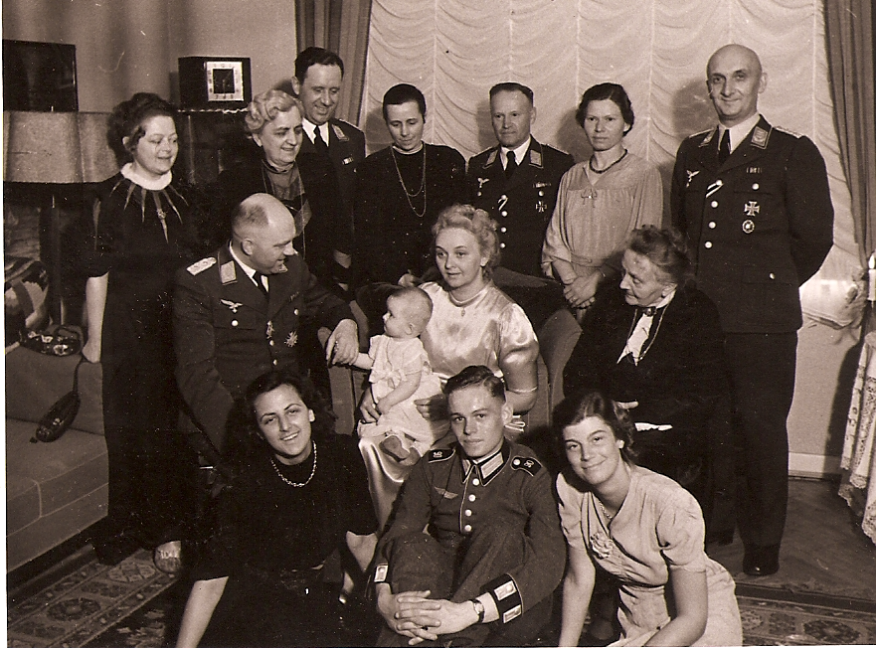

Paul continued the military tradition and served as a cavalry officer. His highest rank was Major. Here he is shown at the christening of his daughter Monika with his second wife, Lena, surrounded by fellow officers.

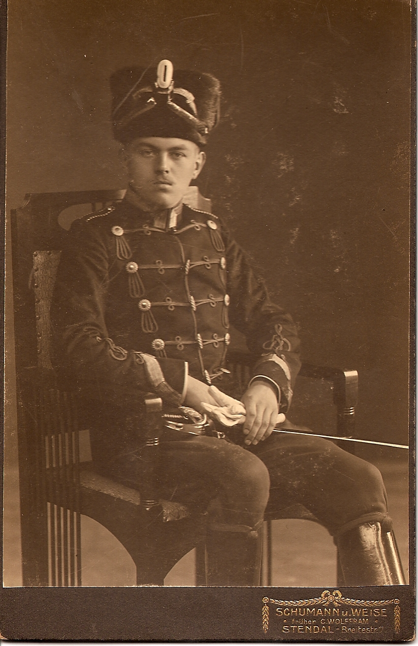

Hans was the acknowledged Black Sheep of the family. After being expelled from numerous high schools and boarding schools for misbehavior and endless pranks, his father bought him a passage to America without telling his mother. Lina, however, found out and “rescued” him literally from the gang-plank in Hamburg harbor and brought him home. His father then bought him a spot in a Hussar regiment, see picture, but he left soon after.

Despite his difficulties, he was very charming and appeared very attractive to the opposite sex. Several engagements were broken off because he could not stop having affairs with others during the time of engagement. He finally impregnated a cousin and had to get married. This was not a happy marriage, and he soon left to join the Freischärler, a right wing military organization, engaging in “liberating” the Eastern Baltic states. After the end of WWII, he spent time in a British prisoner-of-war camp. After his release, he moved in with us in Frankfurt. There followed an endless succession of elderly women all very interested in visiting Onkel Hans. It is interesting to know that his death in 1955 was brought about by his womanizing; he had been admitted to the hospital with a blod clot and put on strict bed rest. During the night, however, he got up to visit a female patient in the next room. The blod clot dislodged and killed him instantly. We don’t know whether before or after...

I got to know him well when we lived together; he was the best story-teller, and had so many adventures to relate, he always had time for you, he cheated at games in an obvious manner (and loved to get caught), and he was always funny and charming. Black Sheep or not - he was my Favorite Uncle.
Ehrhardt / Preibisch
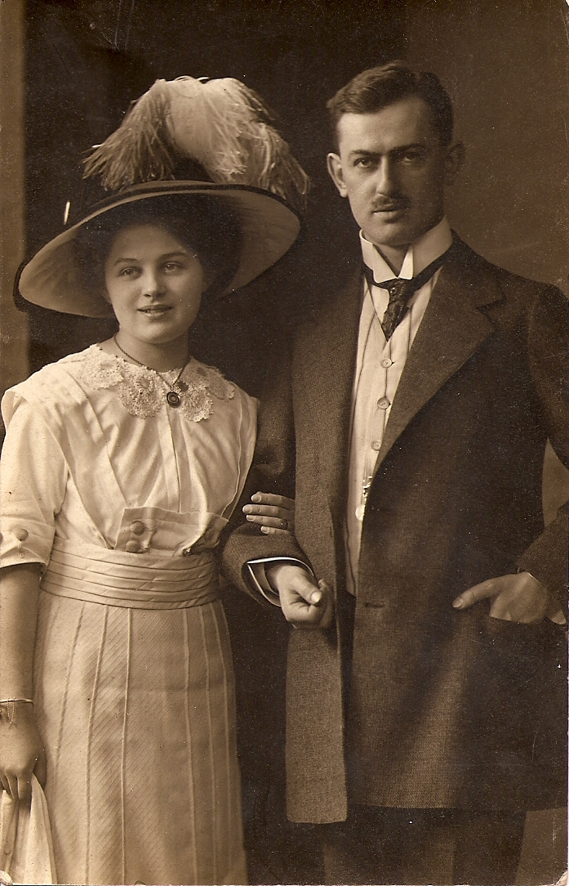
When Louise Ehrhardt and Walther Preibisch announced their intention to get married, both families were taken aback. The Ehrhardts felt the Preibischs were somewhat suspect with their intellectual discussions and all that music playing, and the Preibischs felt the Ehrhardts were a bit stodgy with their horses and many servants. Moreover, they did not know what to do with a daughter-in-law who couldn’t even carry a tune. Nevertheless, Louise and Walther were married on October 2, 1912.

The wedding was a grand affair: The ceremony was followed by a nine-course dinner, each course paired with the appropriate wine, and ending with champagne. Introducing each course, the string quartet played a carefully chosen selection of wedding music. Below, a copy of the menu:

Coronation March from the opera “The Prophet” by Meyerbeer
Caviar on Ice
with Kupferberg Gold (wine)

Overture to the opera “The Wedding of Figaro” by Mozart
Königinsuppe (“Queen’s Soup”, White Wine Soup with Chicken & Mushrooms)
with Chateau Yquem

Wedding Chorus from the opera “Lohengrien” by Wagner
Back of Veal garnished with Vegetables
with Enkircher Langoa Barton 1904

Love Song from “The Ride of the Valkyries” by Wagner
Turbot in Mushroom Sauce
with Eltviller Taubenberg 1889 (Louise’s year of birth)

Fantasy from the opera “Der Freischütz” by Weber
Pheasant with Pineapple-Sauerkraut, Fruit Compote, and Salad
with Deinhard Cabinet (champagne)

Minuet from “Don Giovanni” by Mozart
Vanilla Ice Cream with Warm Chocolate Sauce

Fantasy from “The Troubadour” by Verdi
Cheese Board

Selections from the Operetta “The Geisha” by Jones
Dessert: Birne Helene (Baked Pears smothered in Warm Chocolate Sauce)

Potpourri from “Die Fledermaus” by Strauss
Mocha
Wiener Blut, waltz by Strauss
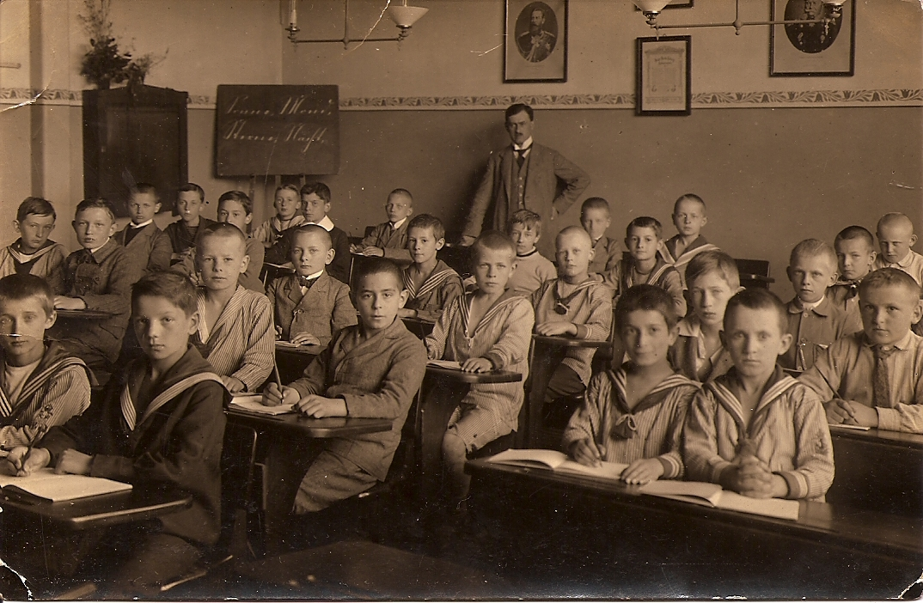
The marriage was a very happy one. Louise had always been somewhat of a rebel – by refusing to wear a corset, insisting on going to college, and now, deciding to use birth control (the newly invented diaphragm), in order to enjoy some time as a two-some. They set up house in Halle, where Walther taught Music and Latin at the Gymnasium.

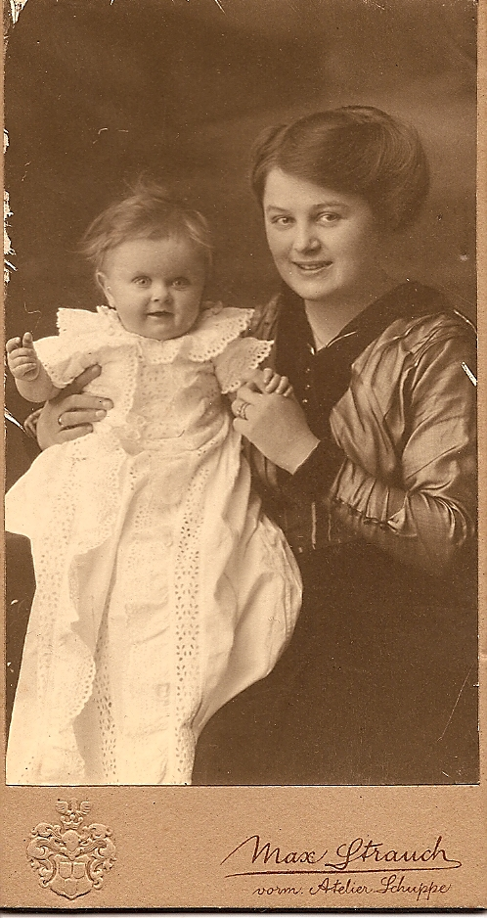
As the music critic for the local newspaper, Walther received tickets to all operas and concerts, and Louise (“Omi”) remembered this time as filled with wonderful musical and social events at the side of her beloved husband.

In 1914, their first daughter Hilde (Hitti) was born. It was the time leading up to
the outbreak of WWI, and they chose the name “Hero” for her in hopes of a good
outcome.

When the war did break out, Walther was drafted and sent to the Western
Front. He managed to come home on leave occasionally and is seen here
in 1917 with his daughter and his pregnant wife.

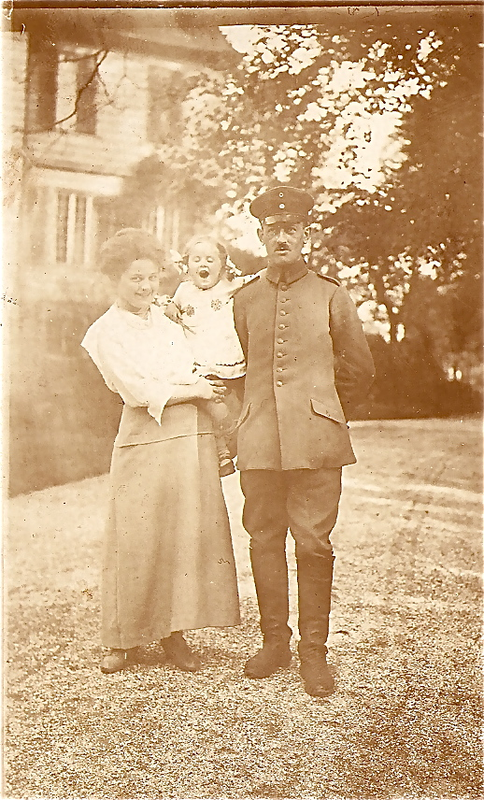
Their second daughter, Vivi, was born in
1918 and was named “Wiltrud Siegfriede”
(the one who wills magic to win peace)
in hopes of an end to the terrible war.

Below is the last picture taken of Walther,
(in front with stein) stationed in the woods
of Ardennes, France. He was killed in 1918, during the last weeks of the war. In a letter to Louise, a fellow soldier wrote that Walther’s last words were: “Tell my dear wife.....” and then he died, mid-sentence.
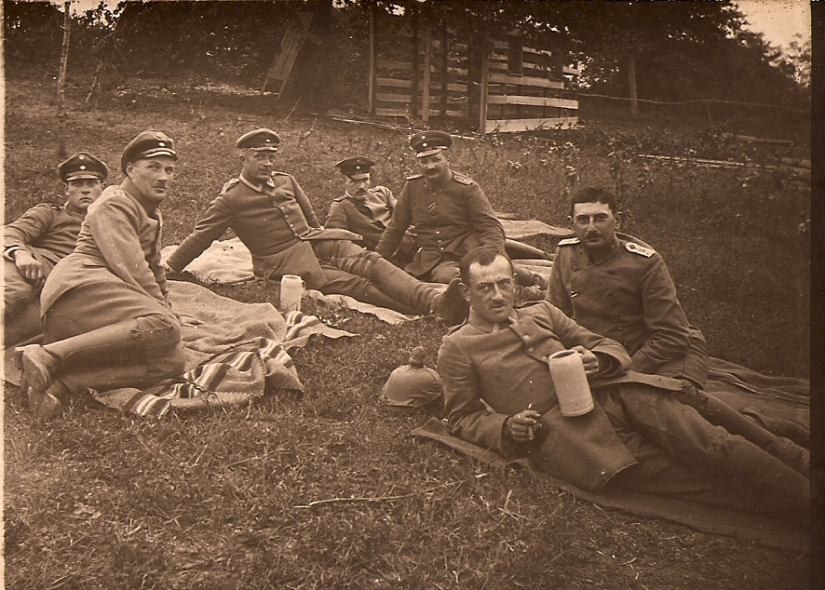

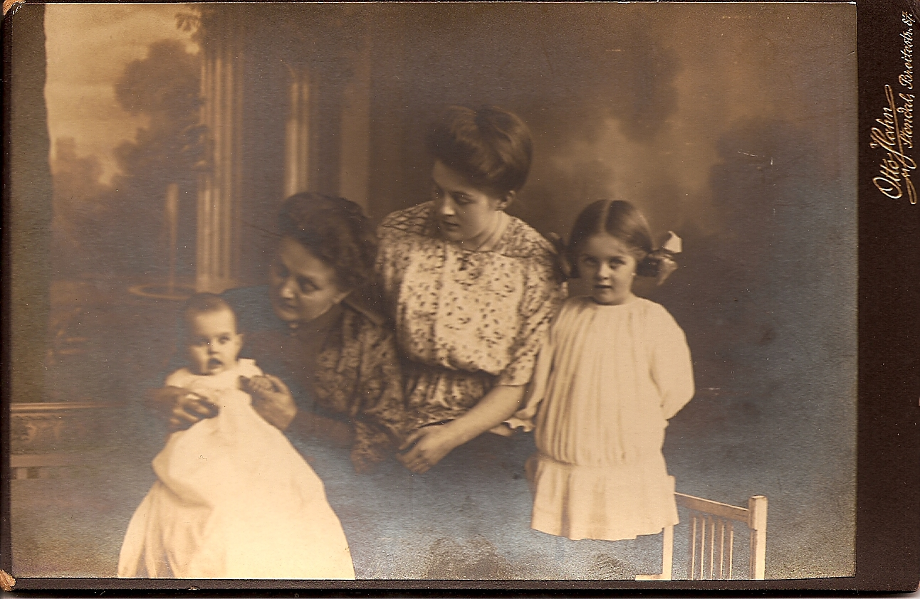
After Walther’s death, Louise
and her two little daughters
moved back to Stendal, into her
parents’ house. Here, she is
seen with her mother Lina,
baby Vivi, and 4 year-old Hitti.

After a period of mourning, Louise
entertained several suitors, but finally
settled on Hans Preibisch, Walther’s
older brother.

Hans and Louise had many common
interests, including an appreciation of
classical literature, especially Homer. She also expected that he would be a good father to her little girls, since he was their actual uncle. However, the marriage eventually proved to be an unhappy one, marked by many infidelities on Hans’ part (including live-in lovers) and his mental and physical abuse of the children. We don’t know why Louise tolerated him, and will never know.

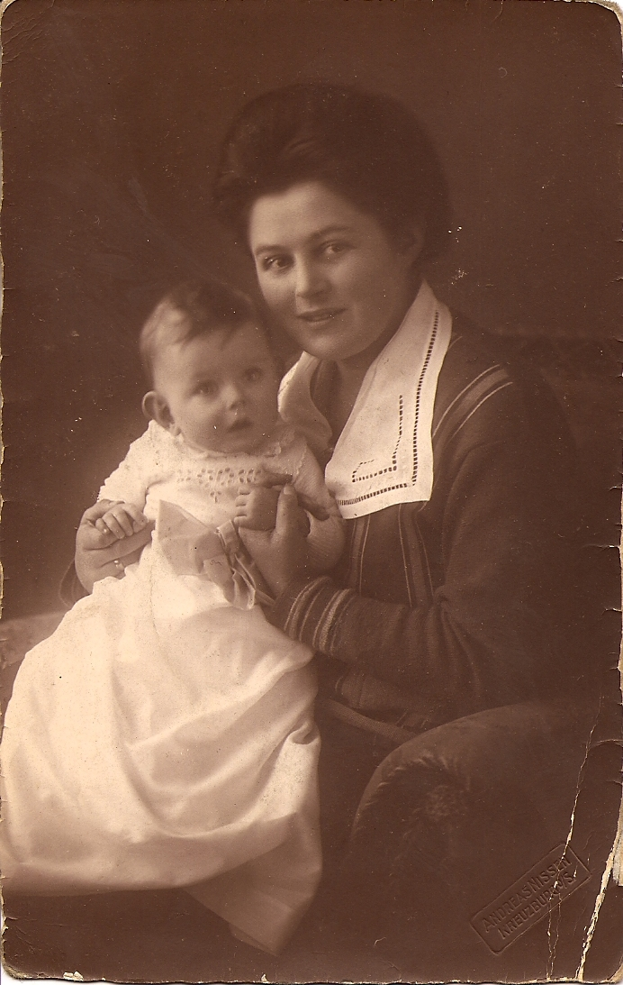
After their wedding, the new couple moved to Kreuzburg, in Upper Silesia (now Kluczbork in Poland), where Hans took on a position as Director of a Gymnasium. The two girls, meanwhile, stayed in Stendal with their grandparents, among the horses, cows, chickens, and the many visitors – a very happy time, as remembered by Vivi.

After a year, Hans and Louise had a son, whom they named Walther
after Louise’s first husband. Hitti and Vivi were now allowed to join
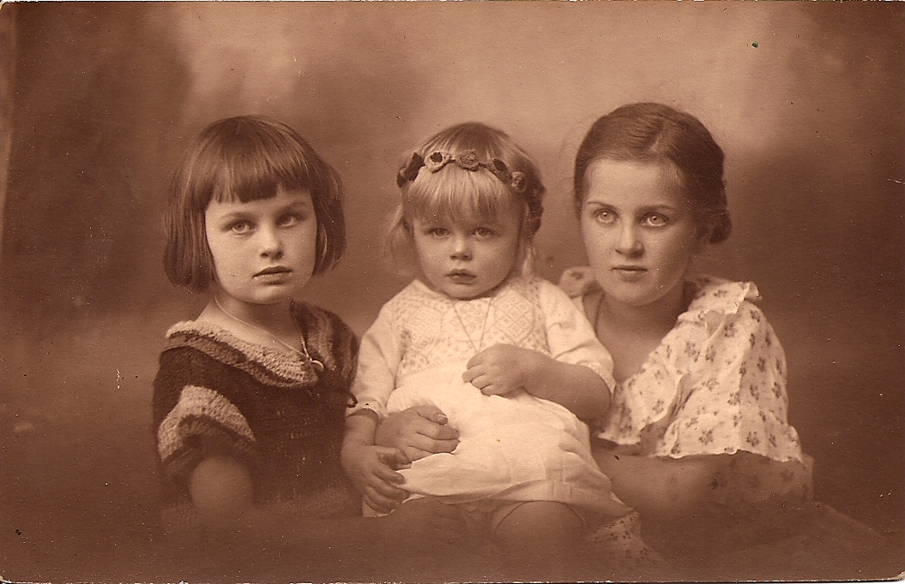
the family in Kreuzburg.
The reunion, however,
was not a happy one,
since the girls suffered
under the tyranny of
their step-father. I believe
the picture of the three
children reflects this clearly.

Hans was then assigned to
a Gymnasium in Hamburg,
and the family moved once more. As the children grew older, it became
clear that Hitti and Walther had inherited the musical genes of the
Preibischs. Hitti grew up to be an organist and music director. Walter had just begun directing his own choir at 17, when he was drafted to fight in WWII. He was killed soon after on the Eastern Front. (For Vivi, see “Vivi’s Remarkable Life”.)

As the Nazi’s came to power, life became difficult for the Preibischs. The required “Passport of Ancestry” documented that Anna Schönfeld (see Schönfeld / Herz) had been baptized as an adult, a possible indication that she had been born Jewish and converted before marriage. Instantly, Hans lost his job, educational options for the children became very limited, and the family was socially ostracized. Vivi emigrated to Japan, Hitti buried herself in her music. Hans, who had always had health problems due to his injuries from WW I took an overdose during a hospital stay, not clear whether intentionally or not.
At 55 years old, at the end of WWII, Louise found herself twice widowed, had lost her teenage son, and had no sign of life of her daughter Vivi and assumed her dead. Moreover, she had lost her house and most of her belongings to the fire-bomb attacks in Hamburg.

Louise collected what was left (remarkably, the Schrank!) and moved in with Hitti into a small room in Wohltorf, where she had her first job as an organist.

Five years later, Louise suddenly received a letter from her long-lost daughter, Vivi: She had not only survived, but had married an American, and had a daughter herself. And she was planning to visit!
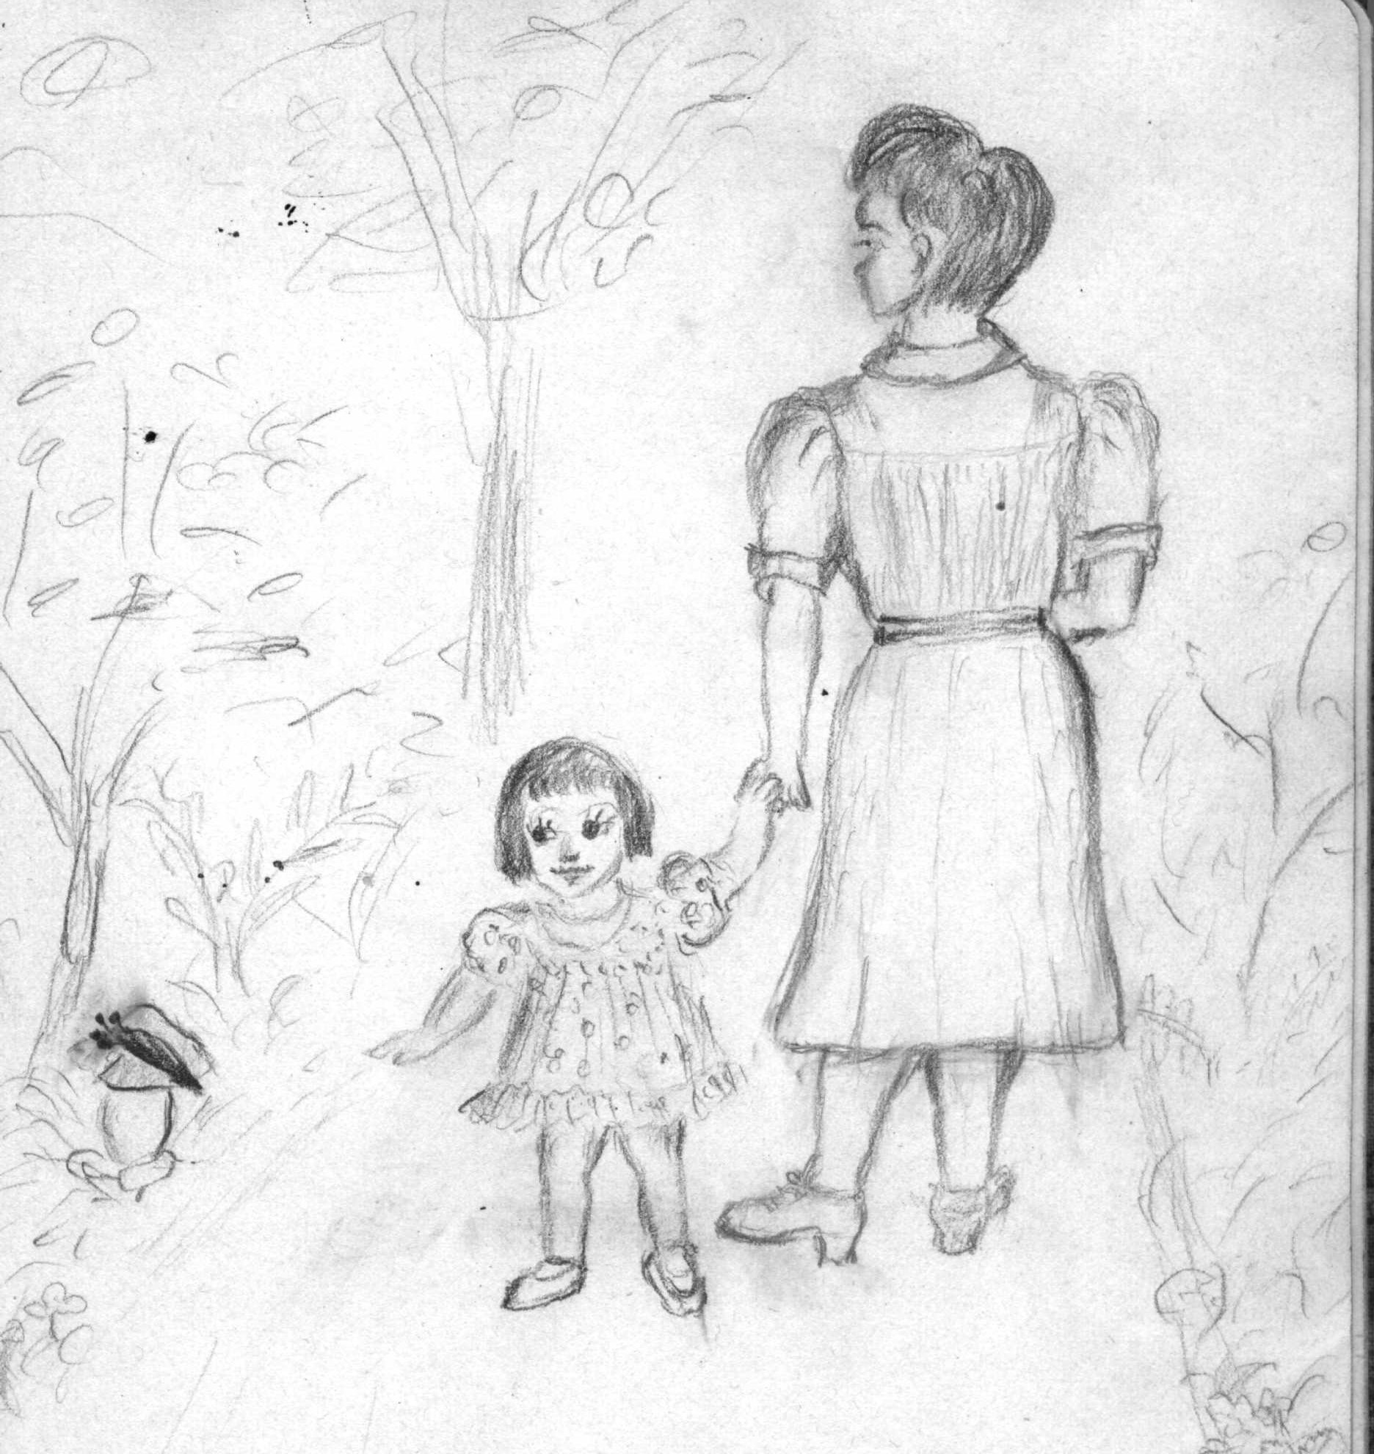
I met Omi when I was two years old. I remember the softness of her lap,
the sweet smell of her sweaters, and our long, long walks through the
woods and meadows. Omi knew everything; the names of the flowers,
the habits of the animals, and how to pick the right mushrooms.

She must have enjoyed these walks as much as I did. Much later,
I found a sketch-book, in which she documented our adventures
together. On the right, a drawing from 1949. (For more on walks with
Omi, see Earth Tales.)

Omi was not only an avid reader, but committed everything she read to
memory. As she became more and more interested in Folklore and
Fairy Tales, she memorized a vast number of stories from all over the world. She then retold them verbatim to an increasing audience of enthusiasts. She soon became known as the “Fairy-Tale Omi”, and people of all ages would stop by for a cup of coffee and a good story. Below, she is relating the adventures of Little Red Riding Hood to her youngest admirers.
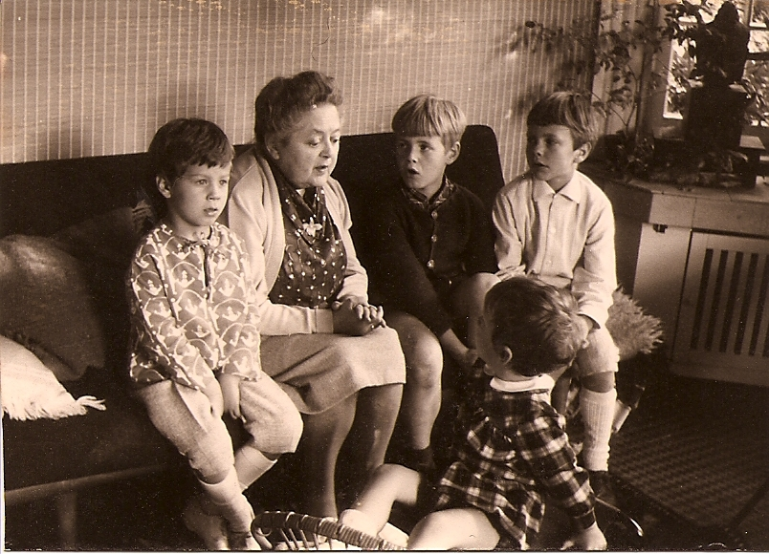

Omi died at age 89, after a stroke. Remarkably, the stroke affected her inhibitions. In her last hours, I was told, she entertained the hospital staff by singing - loudly and off-key - songs from her youth with quite explicit lyrics, much to the embarrassment of her daughters. She apparently died with happy memories.

The thing I admire most about Omi is, that despite all her sad experiences and horrible losses, she retained an enthusiasm for life and the belief in the goodness of people.

